**PM SHRI KENDRIYA VIDYALAYA**

**MISA CANTT, NAGAON**



**COMPUTER SCIENCE PROJECT**

**KV MISA Attendance System**

**(Session 2024-25)**

**Prepared by : MOHD. FARMAN USTA**

**&**

**Himanshu Gupta**

**Class : XI A**

**Roll number : 6, 7**

**Submitted to : Mr. DHIRAJ GHOSH SIR**

**CONTENTS**

1. ACKNOWLEDGEMENT

2. CERTIFICATE

3. OBJECTIVE

4. FUTURE GOALS

5. ALGORITHM

6. FLOW CHART

8. SOURCE CODE

9. LIBRARIES INSTALLED

10. OUTPUT



**ACKNOWLEDGMENT**

It is with pleasure that I acknowledge my sincere gratitude to our teacher, **Dhiraj Ghosh** . who taught and undertook the responsibility of teaching the subject computer science. I have been greatly benefited from his classes.

I am especially indebted to our Principal **Praveen Kumar** **SHERMA** who has always been a source of encouragement and support and without whose inspiration this project would not have been a successful I would like to place on record heartfelt thanks to him.

Finally, I would like to express my sincere appreciation for all the other students for my batch their friendship & the fine times that we all shared together.

**MOHD. FARMAN USTA**

**&**

**Himanshu Gupta**

**Class: XI A**

**CERTIFICATE OF COMPLETION**

*This is to certify that* ***Mohd. Farman Usta*** *and* ***Himanshu Gupta****, students of Class XI A of KV Misa Cantt, have successfully completed their project titled* ***“KV MISA Attendance System”*** *under my supervision.*

*They have demonstrated great interest and utmost sincerity throughout the project, adhering to the guidelines issued by CBSE, New Delhi. Their efforts in developing this attendance management system reflect their dedication to their studies and technical skills.*

*I hereby certify that this project meets my expectations and contributes significantly to their learning experience.*

________________ ________________

**Internal Examiner External  Examiner**

**___________**

**Principal**

**OBJECTIVES**

The objective of the KV MISA Attendance System Python project is to develop a software application that enables teachers to easily take attendance online. This project aims to streamline the attendance process and eliminate the need for traditional attendance registers.

This project is built on fundamental concepts of Python programming, focusing on GUI development, data management, and user interaction.

In this system, teachers can:

Record attendance for students by selecting their status as "Present" or "Absent."

Save attendance data to a file for future reference.

Generate and send a summary report via WhatsApp.

The system provides an intuitive interface that allows teachers to efficiently manage attendance while ensuring accuracy and ease of use.



**FUTURE GOALS**

**Enhance the GUI Design:** Make the graphical user interface more visually appealing and user-friendly for easy navigation and a better experience.

**Expand Usability Across Classes:** Adapt the project to handle attendance for multiple classes within the school, allowing teachers from different classes to use it.

**Automated Messaging to Parents:** Implement a feature to send automated messages to parents, notifying them if their child is absent on a particular day.

**Easily Manage Student Records:** Enable teachers to add or remove student names quickly, making it simpler to keep the records up-to-date.

**Integrate with Excel Sheets:** Connect the project to Excel sheets for easy data storage and management, making it straightforward to export or import attendance records.



**ALGORITHM**

**STEP - 1** : ***START***

**STEP - 2** *Get Password*

**STEP - 3** : *Collect Attendance*.

**STEP - 4** : *Submit Attendance*

**STEP - 5** : *Save Attendance to File*

**STEP - 6** *Send WhatsApp Message*

**STEP - 7** : ***STOP***

**FLOW CHART**

**SOURCE CODE**

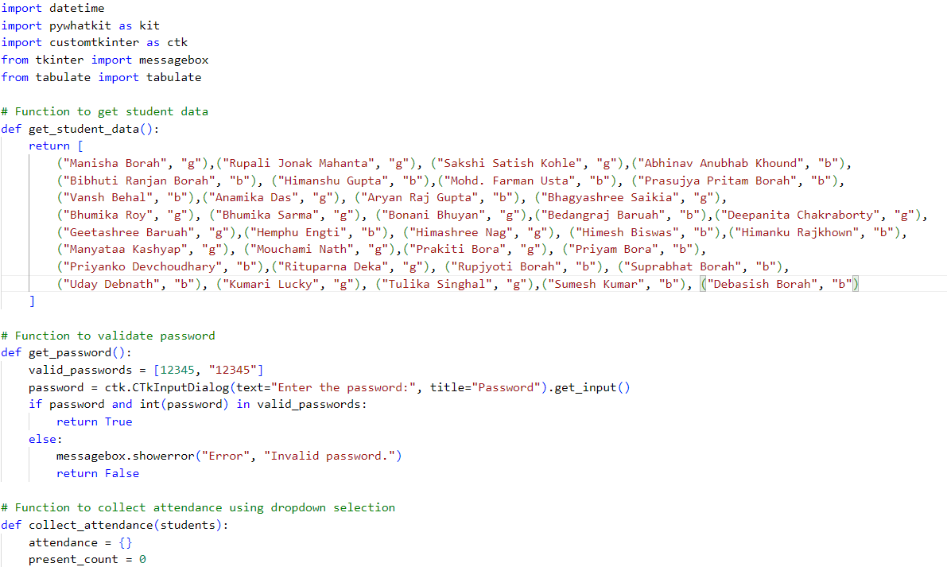

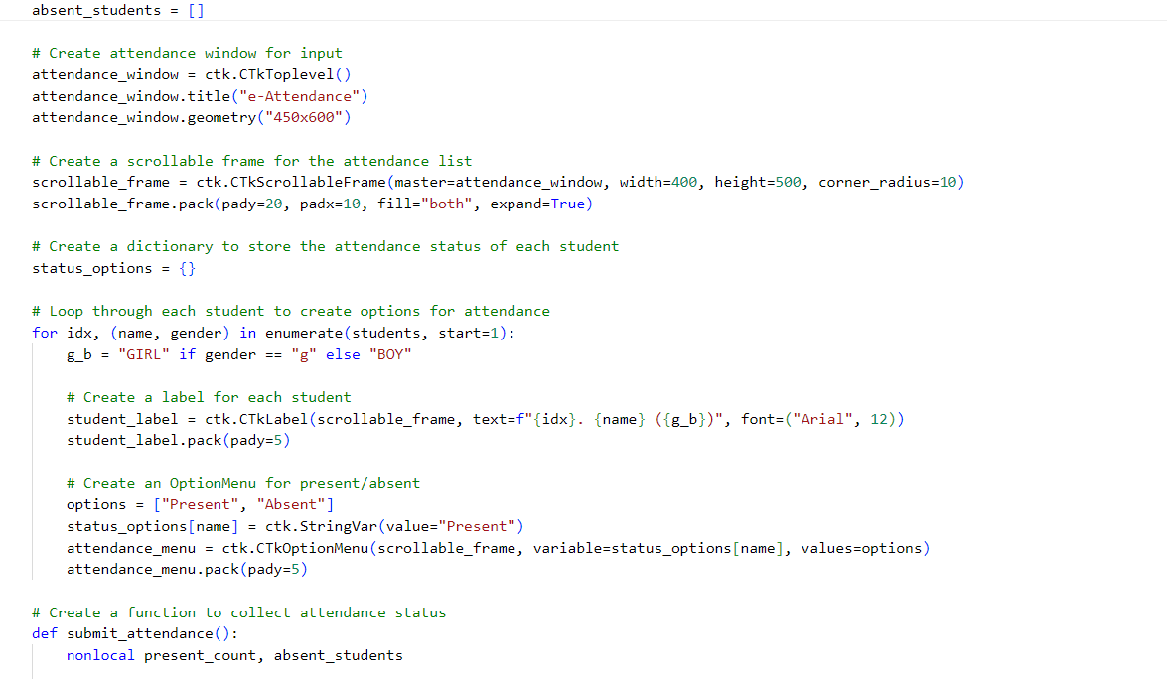

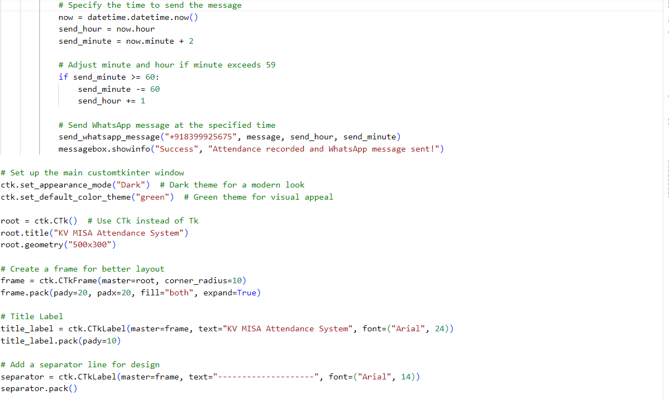

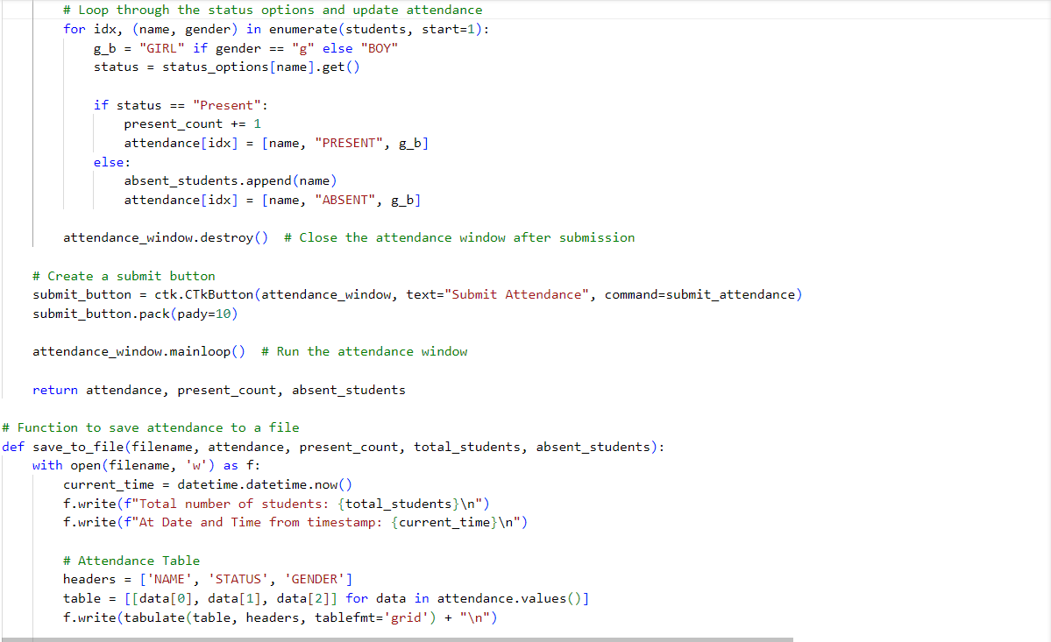

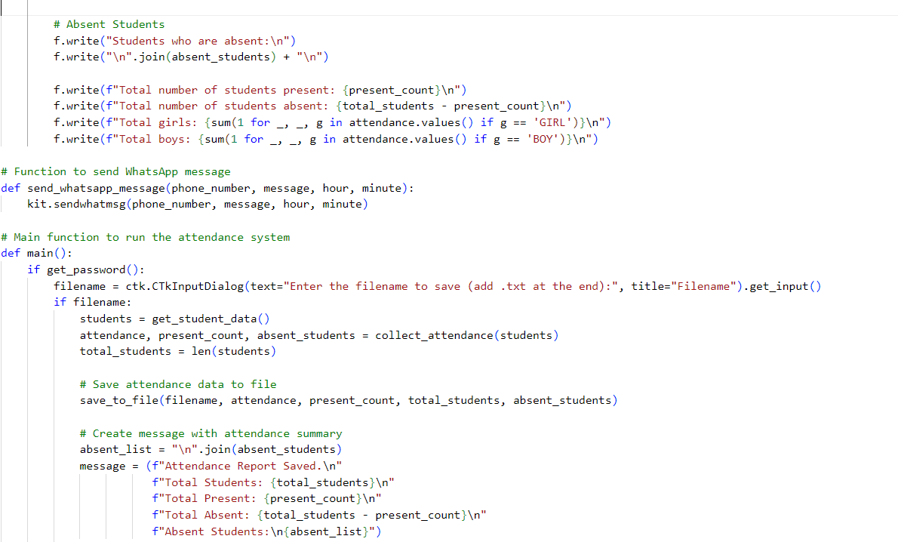

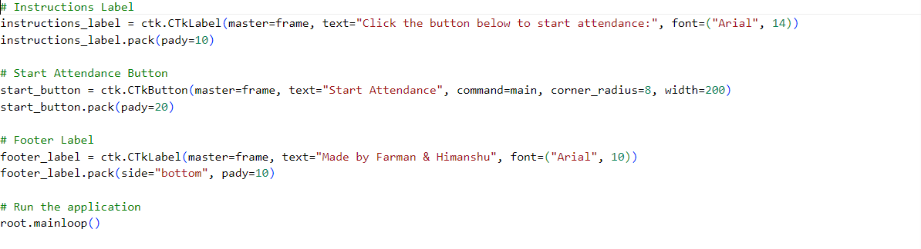

LIBRARIES INSTALLED

**pip install customtkinter**

**pip install pywhatkit**

**pip install tabulate**

**OUTPUT**

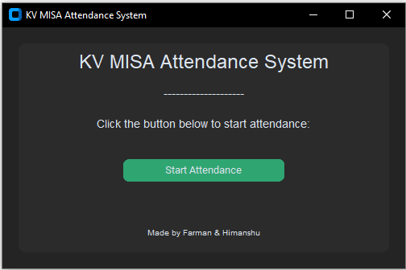

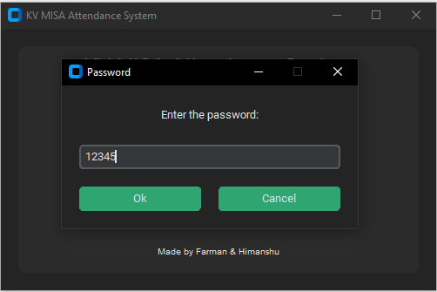

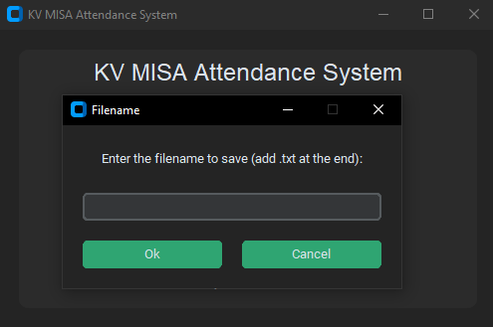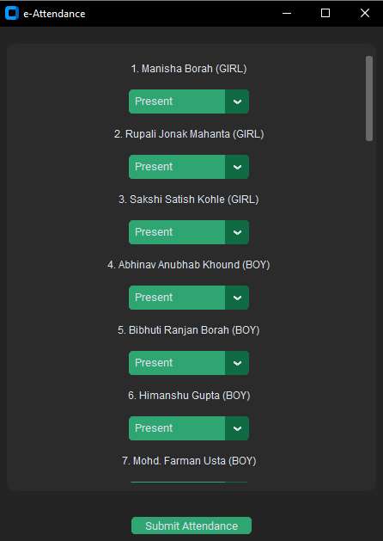

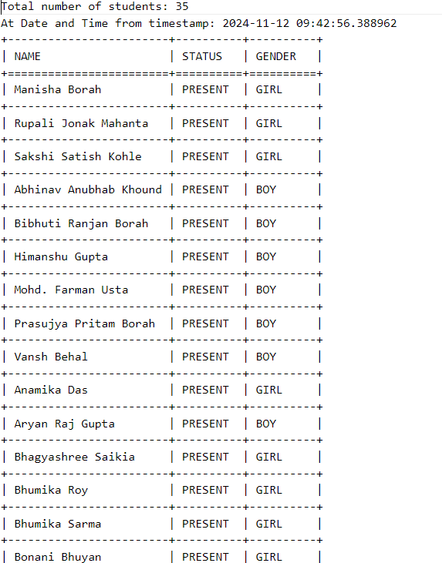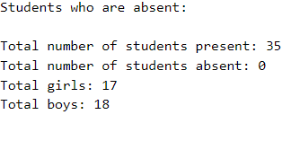

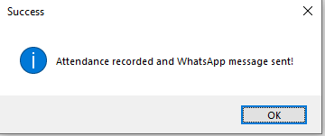

**BIBLIOGRAPHY**

[www.python.org/download](http://www.python.org/download)

[www.google.co.in](http://www.google.co.in/)

<https://code.visualstudio.com/Download>

<https://chatgpt.com/>